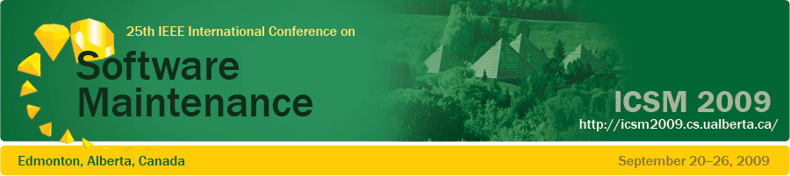
Important Dates  - April 3, 2009:  Abstracts due  - April 10, 2009:  Research papers due  - May 1, 2009:  All other submissions due  - May 29, 2009:  Notifications sent to authors  - June 26, 2009:  Camera-ready papers due | ICSM is the premier international event in the software maintenance field for participants from academia, government, and industry to share ideas and experiences for solving critical software maintenance problems. The 25th International Conference on Software Maintenance (ICSM 2009) will be held in Edmonton, Alberta, Canada, one of the most vibrant cities in Canada bordering the beautiful Canadian Rockies.  We invite high quality English-language submissions to all conference tracks. Submissions should follow the IEEE CS proceedings style.  Research Papers: Research papers should describe original and significant work in the research and practice of software maintenance and evolution. Case studies, empirical research, and experiments are particularly welcome. We also welcome papers that present leading-edge ideas in maintenance. Papers must not have been previously accepted for publication nor concurrently submitted for review in another journal, book, or conference.  Industry Track: This track invites proposals for presentations of industrial applications and practices. These proposals can include state-of-the-art descriptions, state-of-the-practice reports, and survey papers from real-world projects and industrial experiences.  Workshops and Panels: We invite proposals for workshops and panels on any topic related to software maintenance. Workshops and panels are to be designed around a specific theme and be interactive and discussion oriented.  Doctoral Symposium: We welcome submissions of young researchers that have delivered their Ph.D. dissertation in the software maintenance and evolution area within the last two years.  Tool Demonstrations: We invite proposals for tool demonstrations on any topic related to software maintenance and evolution. Demonstrations will be in an open session to allow individual interaction with the participants.  Topics of interest include but are not limited to:  - Experience reports  - Techniques, methods and processes:  - to facilitate and support software maintenance  - to analyze and comprehend software systems  - to specify, design, implement and test evolvable systems  - Maintenance and evolution of multi-language, multi-platform and, network-centric systems  - Model driven software maintenance and evolution | Sponsors    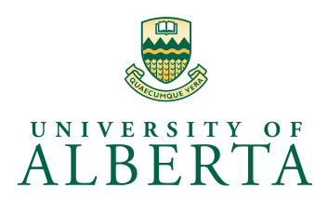      \  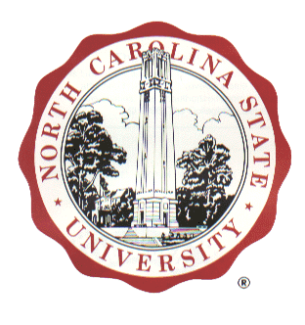
General Chair
Eleni Stroulia
University of Alberta
Program Chairs
- Kostas Kontogiannis
National Technical U Athens
- Tao Xie
NC State University
Doctoral Symposium
Chairs
- Arie Van Deursen
Delft University
- Ahmed E. Hassan
Queens University
Industrial Track
Chairs
- Hausi Mueller
University of Victoria
- Carl Worms
Credit Suisse
Tool Demo Track Chair
Mark Grechanik
Accenture Technology Labs
Publicity Chair
Jens Krinke
King's College London
Proceedings Chair
Dirk Beyer
Simon Fraser University
Finance Chair
Ken Wong
University of Alberta
Collocated Events
- SCAM
- WSE
- VISSOFT
See you in Edmonton!

